TECIS 2016

The 17th annual international conference of the IFAC TC 9.5 (TECIS 2016, formerly “SWIIS”) was organised by the Austrian and Kosovo IFAC NMO and took place in Durres, a beautiful city on the Adriatic Riviera in Albania between October 26th to 28th, 2016.

IFAC TECIS 2016 provided a forum for professionals, researchers, experts, and practitioners from industry, non-governmental organisations (NGOs) and academia to give an overview of the state of the art, to present new research results and to exchange ideas and experiences in the field of the role of control and automation technologies and praxis in promoting international stability. A related goal of this Conference was to propose new approaches in dealing with globalization effects, and investigating international system complexity and the management of knowledge in that context.

As one of the first IFAC events in a non IFAC member country and according to the scope of TECIS, this event offered scientists from Kosovo, Albania and across the Balkan region generally the opportunity to present their research results at an IFAC sponsored international event.

The 61 contributions included 5 plenary talks, 1 plenary discussion, 5 invited papers and 50 regular papers. They covered a very broad field subjects including Social Aspects of Technology Transfer, Globalisation Impact of International Stability, Control Education and International Stability, Engineering Ethics, Cultural Effects, Knowledge Management and Intelligent Systems, Complex Adaptive Systems, Technology and Environmental Stability, Cost Oriented Automation (COA) and End of life Management (EoL).

The plenary papers were presented by T.Duda (CH) “3D Metal Printing Technology”, P.Groumpos (GR) “ Deep Learning vs. Wise Learning: A Critical and Challenging Overview”, E.Hajrizi (KOS) ” Smart Solution for Smart Factories”, N.Jesse (GER) “Internet of Things and Big Data – the Disruption of the Value Chain and the Rise of New Software” and P.Kopacek (AUT) “Development Trends in Robotics”.

During the conference, at the end of each day, the Young Members working group supported by the TC chairperson, organised “reflective sessions”. These sessions invited members to reflect on the proceedings of each day and share perspectives on what the contributions meant for IFAC agenda in the international stability space and were gathered together each day. At the end of the conference, a panel session was organised entitled “Towards a New Agenda for Systems Engineering and International Stability”, chaired by L. and A. Stapleton (IL), which synthesised key ideas from the reflections and from a series of break-out focus group contributions during the session. The panel session and the reflective sessions incorporated contributions from international networks of young European engineers (ESTIEM), NGOs (e.g. MITRA Trajectoires), industry and academia. The outputs from this activity provides the basis for a contribution for the 2017 World Congress and sets out engagement opportunities and basic elements of a framework for engagement for IFAC, CC9 and especially TC 9-5 in the current international context.

The conference hotel was located at one of the famous, endless Albanian sandy beaches. A technical visit was organised to a fully automated brewery including beer tasting and to Tirana the capital of Albania. The social program included a banquet dinner with famous Albanian music and traditional dancers. To give the international participants an impression on the landscape and the history of Albania a full day excursion to the roots of Albania – the castle of Skanderbeg (the founder and national hero of Albania) in Krujë and his grove in Lezhë including lunch on the golden beach of Shëngjin.

We are extremely grateful to the International Program Committee (IPC) members for reviewing of the papers, the members of the National Organising Committee (NOC) for the successful organisation of the event and especially to all attendees for participating in and contributing to this event and we hope that you enjoyed the familiar atmosphere which stimulated intensive and successful discussions.

Peter Kopacek and Larry Stapleton
IPC Vice Chair IPC Chair

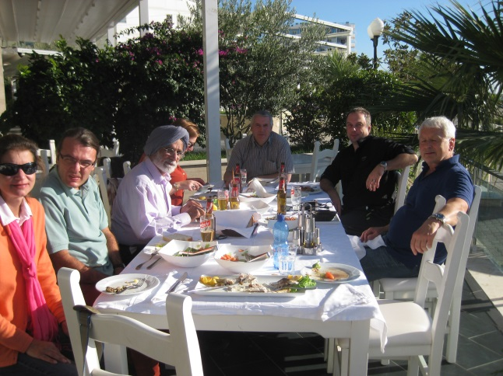
Lunch in Shëngjin

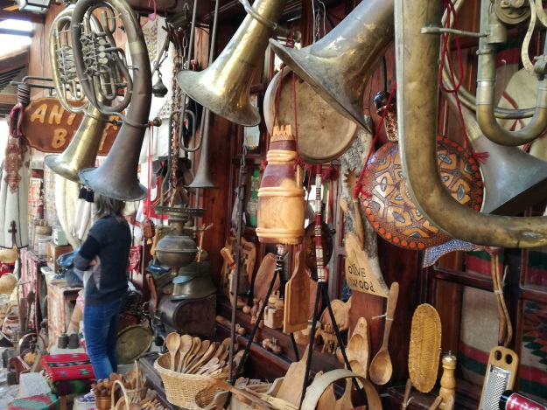
Basar in Krujë

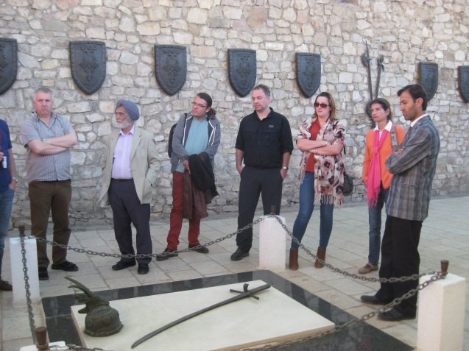
Tomb of Skanderbeg in Lezhë

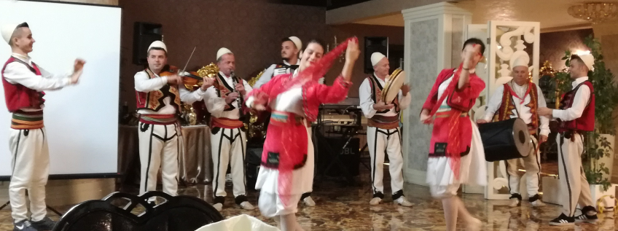

Albanian folklore group

