IFAC TECHNICAL COMMITTEE (TC)
ANNUAL REPORT

Report covering period
(This report, in addition to the conference list and statistics derived from the IFAC conference data base (as attached), represents the workings of the TC. The TC Chair’s report and recommendation of the TC are integrated to the Technical Board report, which in turn is reported to the Council and the General Assembly. Therefore, accuracy and completeness are vitally important.)

TC Number TC5.3
TC Name Integration and Interoperability of Enterprise Systems (I2ES)

TC Chair: Qing Li
e-mail: liqing@tsinghua.edu.cn

TC Vice Chair Name (Industry): Georg Weichhart
e-mail: georg.weichhart@primetals.com
TC Vice Chair Name (Education): David Romero
e-mail: dromero@itesm.mx
TC Vice Chair Name (Social Media):
e-mail:
TC Vice Chair Name (Publication Liaison)
e-mail:
TC Vice Chair Name (others)
e-mail:
TC Vice Chair Name (others)
e-mail:
TC Vice Chair Name (others)
e-mail:
TC Vice Chair Name (others)
e-mail:

Have you updated your membership roster? Yes No
- Number of TC members 41
- Number of members from industry 2
- Number of women members 4
- Number of countries represented in TC 18

Have you sent your membership roster to the Secretariat? Yes No
Date of the most recent update to the Secretariat:

Have you updated your TC scope? Yes No

Have you created/amended your TC website? Yes No
Date of last update: Autumn 2024

List of Working Groups
- Name:
- Focus:
- Activities:
- Results:

TC Awards: IFAC TC Award Systems Integration and Interoperability

TC Meetings: Date / Place / No. of attendees:
- Previous year:
  - World Congress 2023, Yokohama, Japan, 9.7.23 – 14.7.23 / 60
  - Enterprise Integration, Interoperability and Networking - 17th EI2N 2023, Workshop, Rome, Italy, 15.11.23 – 17.11.23 / 60
- Current year:
  - 18th IFAC Symposium on Information Control Problems in Manufacturing - (INCOM 2024) Vienna, Austria, 28.8.2024-30.8.2024 / 20
  - Enterprise Integration, Interoperability and Networking - 18th EI2N 2024, Workshop, Porto, Portugal, 21-22 November 2024 / 20
- Next year: <date>, <place>, <number of attendees>
  - Enterprise Integration, Interoperability and Networking - 19th EI2N 2025, Workshop, 23-24 October, 2025, Marbella, Spain

__________________________________________________________________________
Congress Year Report (only for congress within reporting period)
- Number of Congress Papers Reviewed by TC
- Number of invited sessions organized by your TC
- Special activities organized by your TC

__________________________________________________________________________
Main sponsored conferences by your TC: <initial lists provided by the Secretariat>, as attached. Please only list the last edition, and the forthcoming edition of the respective series. You can filter for your TC in the respective column.
Moreover, all of you got the respective conference reports via e-mail. Furthermore, received conference reports are also posted in the IFAC Cloud:
https://cloud.ifac-control.org/index.php/s/r27qyP2ysCSG4PF

Past conferences (reporting period): date / place / no. attendees
  - Enterprise Integration, Interoperability and Networking - 18th EI2N 2024, Workshop, Porto, Portugal, 21-22 November 2024 / 20
  - 18th IFAC Symposium on Information Control Problems in Manufacturing - (INCOM 2024) Vienna, Austria, 28.8.24-30.8.24 / 20
  - 5th International Conference on “Innovative Intelligent Industrial Production and Logistics”, IN4PL 2024, to take place in Porto, Portugal, from November 21-22, 2024 /20
Forthcoming conferences: date / place / status (planned, applied, approved)
  - Enterprise Integration, Interoperability and Networking - 19th EI2N 2025, Workshop, 23-24 October, 2025, Marbella, Spain / approved
  - 6th International Conference on “Innovative Intelligent Industrial Production and Logistics”, IN4PL 2025, to take place in Marbella, Spain, from October 23-24, 2025 / approved

Co-sponsored conferences by your TC: <initial lists provided by the Secretariat, as attached>

Past conferences (reporting period): date / place / contribution of your TC
  - Advanced Maintenance Engineering, Services and Technology - 6th AMEST 2024, 12/06/24-14/06/24, Cagliari, ITALY, co-sponsor
  - Mining, Mineral and Metal Processing - 7th MMM 2024, 04/09/24-06/09/24, Brisbane, AUSTRALIA, co-sponsor
Forthcoming conferences: date / place / planned contribution of your TC

Actions performed for DIVERSITY:
- Looking explicitly for a heterogeneous IPC for main sponsored events – this refers to country of origin and gender.
- Selected people for vice chairs from different continents;
- Selected female colleagues to serve as vice chairs;
- Networking of female colleagues in an education cross-TC meetings

Actions performed for YOUNG RESEARCHERS:
- Initiative to invite young colleagues to the TC
- Involve young colleagues e.g. in the Awards committee but also as Vice Chairs.
- Plan to establish TC5.3 student members for PHD student.

Highlights of the reporting period?
- The TC meeting was held on August 29, 2024 during the INCOM 2024, organized by Qing Li, the TC5.3 Chair.
- The EI2N workshop' cafe was held on 22 November 2024 during the EI2N 2024.
- organised a special section of Annual Reviews in Control (ARC) entitled "Control for Cognitive Systems" with extended versions of a selection of papers presented at the IFAC WC 2023.
- organised a special issue of the Journal of Industrial Information Integration entitled " AI for Information Integration and Processing in Digital Twins (AI4IIP-DT)" with extended versions of a selection of papers presented at the IFAC INCOM 2024, the conference IFAC/IEEE/INSTICC IN4PL and the workshop IFAC/IFIP EI2N.
- At INCOM 2024, CC5 Panel "Resilient, Digital and Sustainable Manufacturing and Supply Chains" (Dmitry Ivanov, Fabio Sgarbossa, Marco Macchi, Qing Li). As the TC5.3 Chair, Qing Li introduced the scope of TC5.3
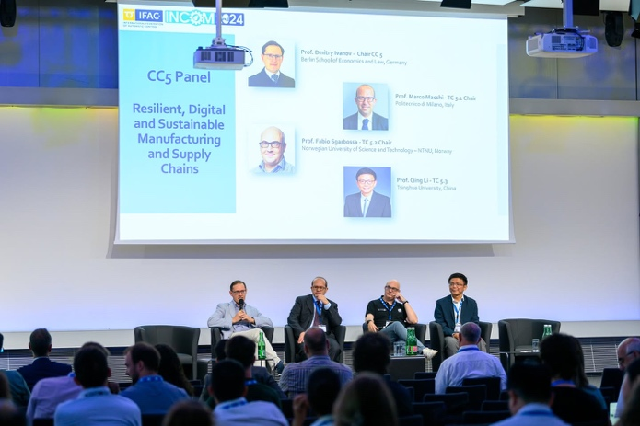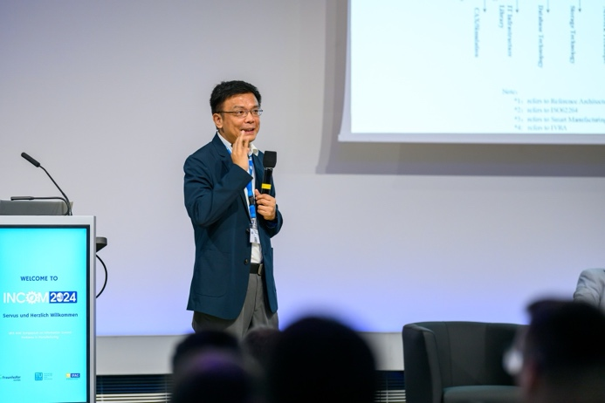

Special activities planned for the next IFAC Congress?
TC Award selection committee will meet to select and announce the third winner of this awards.

Problems - especially any that require TB attention?
Thanks – no support required.

What is the long-term outlook for the scientific topics of your TC?
Please describe likely future major developments within the scope of this TC
The rapid development of intelligent technology and its application in enterprise operations are currently the main scientific challenges faced by TC5.3:
(1) How to correctly understand the operating mechanism of artificial intelligence and form a system structure related to artificial intelligence requires new developments in enterprise engineering technology and enterprise modelling technology;
(2) The bidirectional understanding and interoperability between natural intelligence and artificial intelligence is a new focus of TC5.3 members;
(3) The development of cyber physics social systems requires support from architecture, methodology, system modelling, and system evaluation techniques;
(4) The integration of artificial intelligence and operational technology, and providing support for the development of related technical tools.

Recommendation
Please provide recommendations relevant to TC operation such as potential new Working Groups, recommendations to merge this TC with another TC, new trends within the technical field covered by the TC that suggest future changes in IFAC scope or activities, etc.)

As the new chairman of TC5.3, I hope to receive the support of CC5 and collaborate with other TCs.
(1) I hope to attract more members to join TC5.3, especially young scholars, to bring new perspectives and increase TC's activity.
(2) I hope to complete the adjustment of TC5.3 Sope in 2024. Enterprise Architecture and Enterprise Modelling are important foundations of TC5.3, which has produced widely influential achievements in this field. Today, with the rapid integration of artificial intelligence technology and enterprise operation technology, architecture, methodology, and system modelling are effective tools for integrating human and cyber physical systems.
(3) I hope to find some new topics in TC5.3, form a working group to conduct collaborative research, and collaborate with organizations such as IFIP and ISO/IEC.
(4) I hope TC5.3 can promote research and discussion on the interoperability technology between natural intelligence and artificial intelligence.

